1. Verify that your ansible installation is available by displaying the version of ansible while logged in as the 'user' user.

[test@tcox3 ~]$ ansible --version

ansible 1.9.2

  configured module search path = None

2. Run the ansible command that lists all of the hosts configured in your control server 'hosts' file for the system.

[test@tcox3 ~]$ ansible all --list-hosts

    tcox5.mylabserver.com

    localhost

    tcox4.mylabserver.com

3. Create a playbook, using the 'AT' module that accomplishes the following:

- Uses SSH

- Logs in to the remote system as 'test' user

- Connects to one server or group from Step #2 above

- The playbook runs as 'sudo'

- Skip gathering remote facts

- Schedule a command to run in 1 minute that lists the contents of /var/log and creates a file in the home directory called at1.log with those contents

[test@tcox3 Playbooks]$ vim at.yml

[test@tcox3 Playbooks]$ cat at.yml

--- # AT MODULE EXAMPLE

- hosts: apacheweb

  user: test

  sudo: sudo

  connection: ssh

  gather_facts: no

  tasks:

    - name: Example of a future command with the AT module

      at: command="ls /var/log > /home/test/at1.log" state=absent

4. Run the playbook and display the results.

[test@tcox3 Playbooks]$ ansible-playbook at.yml

PLAY [apacheweb] **************************************************************

TASK: [Example of a future command with the AT module] ************************

ok: [tcox4.mylabserver.com]

PLAY RECAP ********************************************************************

tcox4.mylabserver.com      : ok=1    changed=0    unreachable=0    failed=0

lab:

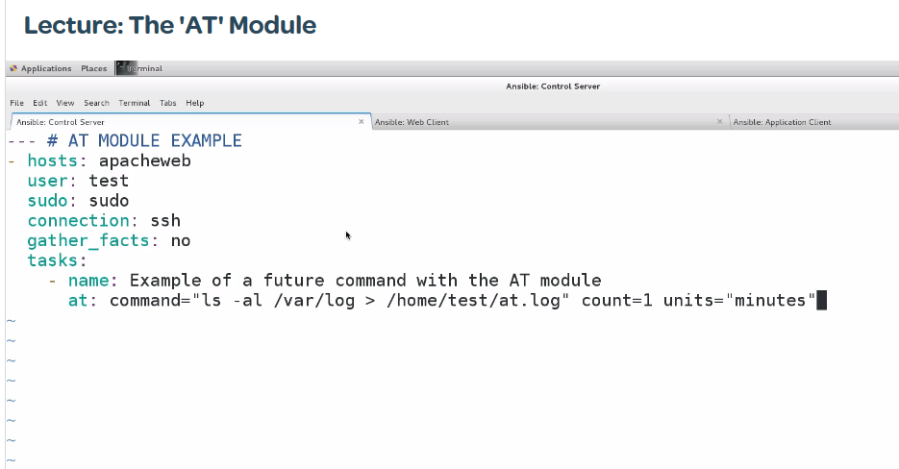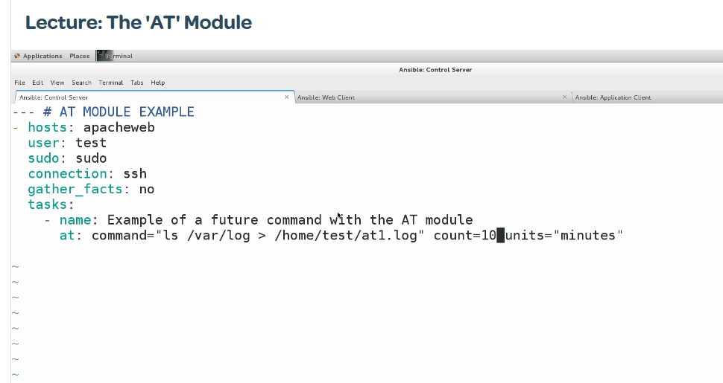

For remove

